**Project Initialization and Planning Phase**

| Date | 15 March 2024 |
| --- | --- |
| Team ID | 739877 |
| Project Name | WCE Curated Colon Disease Classification using Deep Learning |
| Maximum Marks | 3 Marks |

**Define Problem Statements (Customer Problem Statement ):**

Medical professionals struggle with manually analyzing large volumes of Wireless Capsule Endoscopy images, leading to delays and potential errors in diagnosing colon diseases. We need an automated, accurate, and efficient deep learning-based classification system to assist doctors, ensuring timely and precise diagnosis to improve patient care.

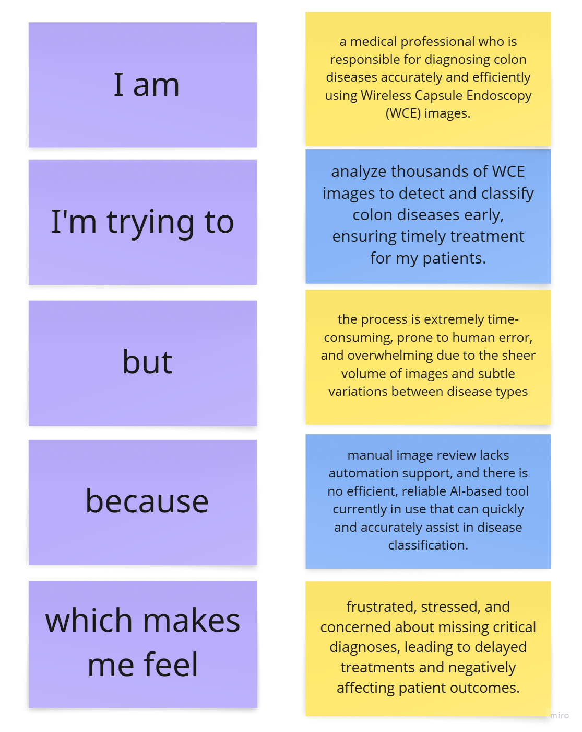

**Example:**

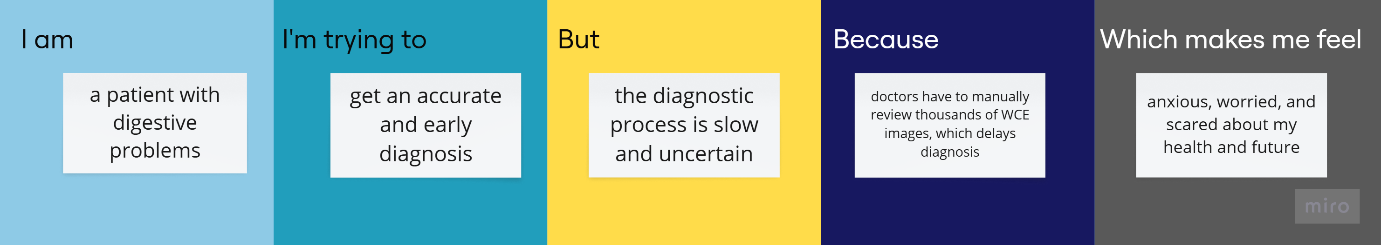

|  |  |  |  |  |  |
| --- | --- | --- | --- | --- | --- |
| **Problem**  **Statement (PS)** | **I am**  **(Customer)** | **I’m trying to** | **But** | **Because** | **Which makes me feel** |
| PS-1 | a doctor who checks colon images | find diseases early and correctly | it takes too long and mistakes can happen | there are too many images and no smart tool to help | stressed and worried about missing important signs |
| PS-2 | a patient with stomach problems | get a fast and correct diagnosis | it is slow and not always right | Doctors need a lot of time to check every image by hand | scared and anxious about my health |